Topics:

* we'll check in with Julio and Dr. Cook on Sunday
* don't need /backend_master/!
* live server might be down - julio's going to check
* we'll be developing on local db/server; follow local server setup guide portion (the first one in docs is for deployment)
* check out atlas compas for mongo gui
* keep documenting any changes made to project
* koa providing errors when trying to local pp db (ex: when creating account on local instance) - specifically errors citing epi:
* module?
* code?
* local db setup?

Julio is going to look into whether live database is down - appears to be down when connecting to cmu website. He also ran a fresh install from remote repo, so he’s seeing what we’re seeing now.

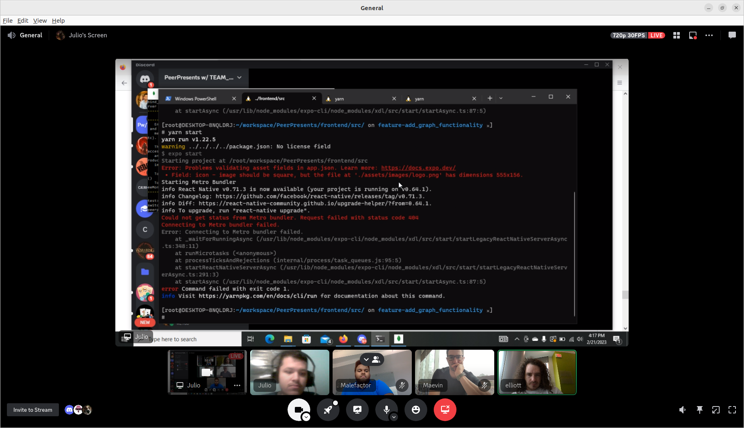

Action items:

* continue dev environment setup
* make sure to document any changes
* looks like the most relevant issue is mongodb config
* Inform him of any changes we made to get frontend running - his isn’t connecting